Week4 Module4 Assignment2
Databases are important because they help organizations store and manage large amounts of information efficiently. However, many users are not familiar with SQL or database systems. Because of this, organizations often create dashboards that allow users to search, filter, and view information easily. For this assignment, I designed a storyboard for a USDA food database dashboard application. The dashboard will use data from PostgreSQL tables including ctgnme, fdes, gpcnme, and wght. The purpose of the application is to allow users to search food products by category and sort the results using a simple visual interface.
1. Identify the Information in the Database That Will Be Represented Visually
The dashboard will visually display important information from the PostgreSQL database so users can easily understand and analyze food product data. The following information will be displayed:
- Food Category Name from the ctgnme table
- Food Description from the fdes table
- GPC Category Information from the gpcnme table
- Weight Information from the wght table .
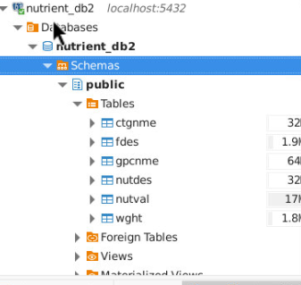
Figure 1: PostgreSQL database tables loaded in DBeaver.
2. Identify How the Data Will Be Represented to the User
A) Which of the data is necessary and unnecessary
The dashboard will represent the data using tables, search bars, dropdown menus, filters, and sorting options.
Necessary Data
- Food category names
- Product descriptions
- Weight information
- Last modified dates
This information helps users quickly understand the food data.
Unnecessary Data
- Internal database codes
- Backend processing details
- Unused columns
Removing unnecessary data keeps the dashboard simple and user-friendly.
B) Dashboard Capabilities
i) Searching
Users can search food products using Food Category Code and Product description keywords. This allows users to quickly locate specific products.
ii) Sorting
Sorting improves organization and readability. Users can sort the results:
- Alphabetically by description
- By last modified date
iii) Filtering
Filtering allows users to narrow down the results and focus on specific data. Users can filter the results by:
- Food category
- Weight information
- GPC category
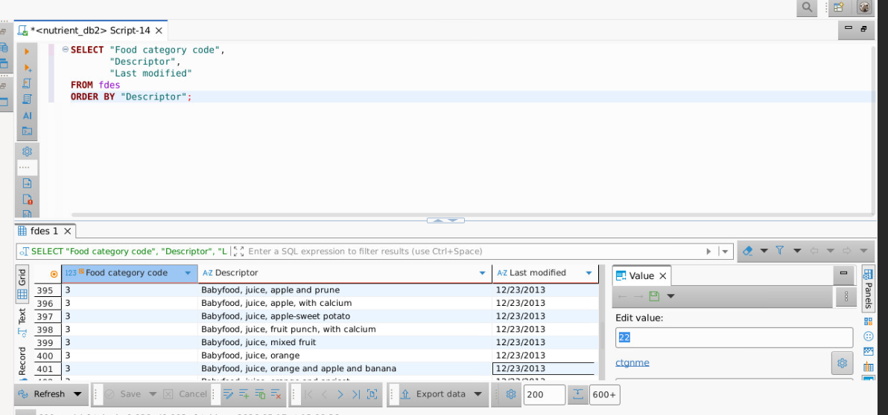
Figure – 2: SQL query displaying food products sorted alphabetically using the descriptor_text column from the fdes table.

3. Storyboard Diagram
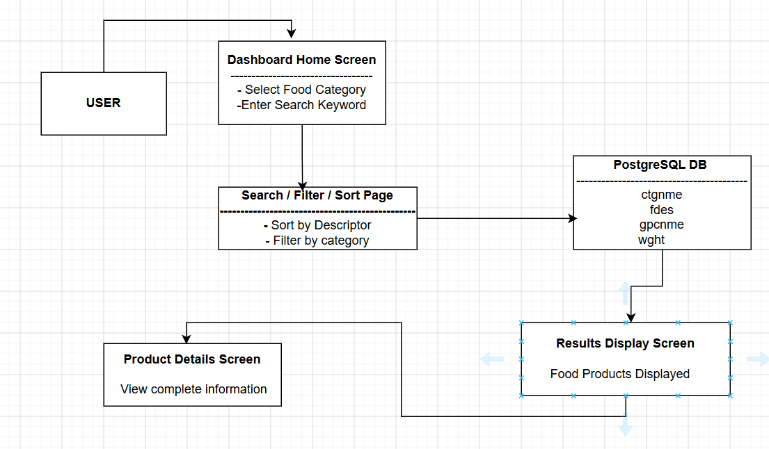
Figure 3: Simple storyboard diagram showing the flow between the user, dashboard application, and PostgreSQL database.
4. Summary of How the Application Addresses the Problem
The application solves the problem by giving users a simple way to access USDA food data without needing SQL knowledge. Instead of manually writing database queries, users can
- Search for food products
- Filter information
- Sort records
- View organized results visually
This makes the system easier to use for non-technical users and improves productivity.
5. Justification for Database Integration
Integrating PostgreSQL with the dashboard provides many advantages.
First, the database stores large amounts of food information in an organized structure. The dashboard retrieves updated data directly from the database whenever users perform searches or filtering. Database integration also provides Faster data retrieval, improved accuracy and easier data management
6. Data Flow Between the User Interface and Database
The data flows through the system in the following process:
- The user interacts with the dashboard interface.
- The user enters search criteria or selects filters.
- The application sends a request to PostgreSQL.
- PostgreSQL retrieves matching records from the database tables.
- The results are returned to the application.
- The dashboard displays the information visually to the user.
7. Explanation of the Integration Pattern
I selected the client-server integration pattern for this application. In this pattern, the dashboard acts as the client and PostgreSQL acts as the server. The client sends requests to the database whenever users search, sort, or filter information.
This integration pattern is useful because:
- It separates the database from the user interface
- It improves security
- It supports future expansion
- It simplifies maintenance
The client-server model is commonly used in modern database applications because it is reliable and scalable.

